Question : 1
Write a Python function calculate_probability(event_count, total_outcomes) that returns the probability of an event, and use it to find the probability of getting 'Heads' when tossing a coin :

def calculate_probability(event_count,total_outcomes):
return event_count / total_outcomes
heads= 1
total_outcomes= 2
probability_heads= calculate_probability(heads,total_outcomes)
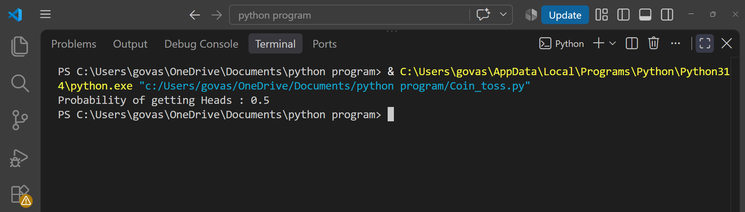
print(f"Probability of getting Heads : {probability_heads}")

So, the probability of getting Heads is 0.5 or 50%.
Question : 2
Simulate rolling a six-sided dice 100 times using Python's random module, count how many times a '6' appears, and calculate the experimental probability of getting a '6'.<br><br><em><strong>Hint:</strong> Use random.randint(1,6) in a loop and keep a counter for '6' : </em>

import random
six_count= 0
total_rolls= 100
for i in range(total_rolls):
roll= random.randint(1,6)
if roll == 6:
six_count += 1
experimental_probability =six_count / total_rolls
print(f"Number of times 6 appeared: {six_count}")
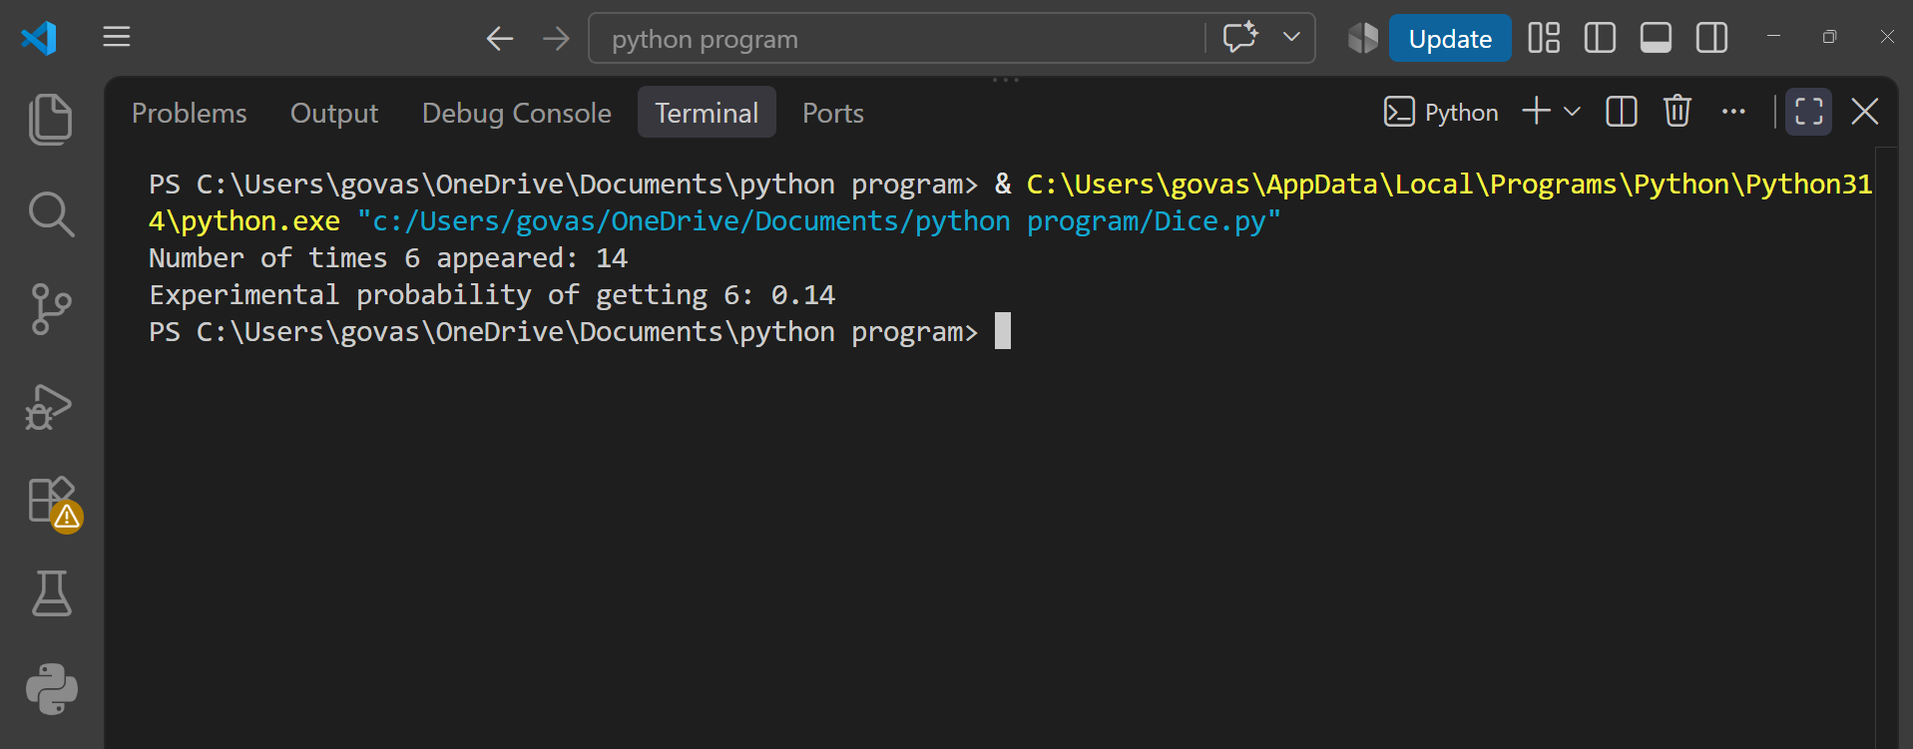
print(f"Experimental probability of getting 6: {experimental_probability}")
Question : 3
Given an array of genres from your last 20 Spotify songs (like ['pop', 'rock', 'pop', 'hiphop', ...]), write code to calculate the probability of randomly picking a 'pop' song from your recent history :
genres = ['pop','rock','pop','hiphop','pop',
'jazz','rock','pop','hiphop','pop',
'rock','pop','jazz','pop','hiphop',
'rock','pop','jazz','rock','pop'
]
pop_count =genres.count('pop')
total_songs =len(genres)
probability_pop =pop_count / total_songs
print(f"Number of Pop songs:{pop_count}")
print(f"Total songs: {total_songs}")
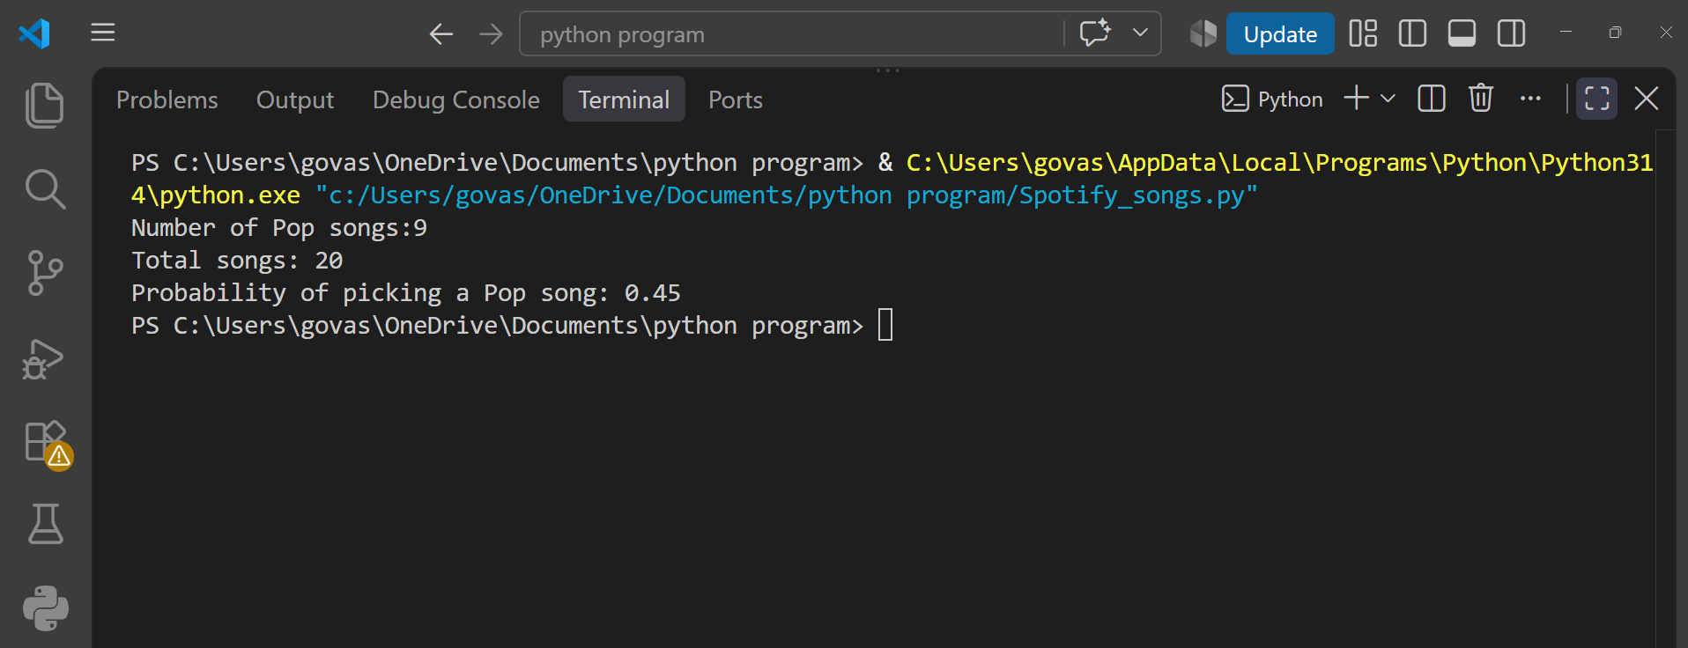
print(f"Probability of picking a Pop song: {probability_pop}")
Question : 4
Write a function that, given two arrays — one for users who ordered food on Zomato and one for users who ordered dessert — calculates the probability that a randomly selected user ordered both food and dessert (i.e., intersection over total unique users) :
def probability_both(food_users,dessert_users):
food_set =set(food_users)
dessert_set =set(dessert_users)
both_users =food_set.intersection(dessert_set)
all_users =food_set.union(dessert_set)
probability =len(both_users) / len(all_users)
return probability

food_users = ['A','B','C','D','E']
dessert_users = ['B','C','F','G']
probability =probability_both(food_users,dessert_users)
print(f"Probability that a user ordered both food and dessert: {probability}")

Here :
- Food users = 5
- Dessert users = 4
- Both = B and C → 2 users
- Total unique users = 7

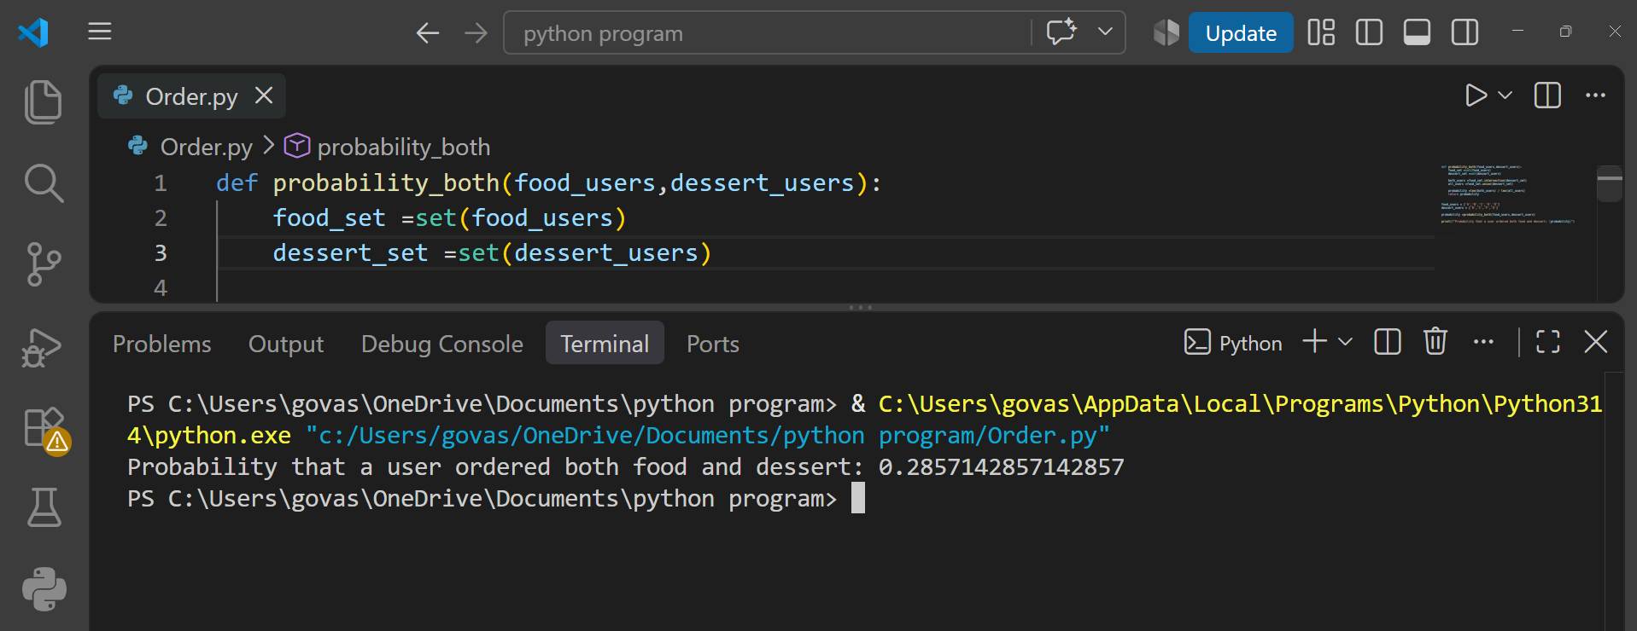
Probability = 2 / 7 ≈ 0.286 = 28.6%

Question : 5
Explain with a short Python code example how conditional probability could be used to improve recommendations in an app like Flipkart (e.g., probability of buying headphones given user bought a phone).<br><br><em><strong>Hint:</strong> Use counts of users who bought both items vs total who bought a phone : </em>

“ Conditional probability can help Flipkart recommend products based on what a customer has already purchased. ”

def conditional_probability(both_count,phone_buyers):
return both_count / phone_buyers
phone_buyers =1000
phone_and_headphone_buyers =250
probability =conditional_probability(
phone_and_headphone_buyers,
phone_buyers
)

print(f"Probability of buying headphones given phone purchase: {probability}")
So, 25% of users who bought a phone also bought headphones.

If a user buys a phone, the app can calculate this probability and show headphones as a recommendation because there is a strong purchasing relationship between the two products.

